Laboratory Report
Linear Surveying and Offsetting
Name:
Student Number:
Institutional Affiliation:
Instructor’s Name:
Date:

Introduction
In an engineering survey, the linear horizontal distance must be determined to complete a survey. Measurement of this linear horizontal distance on the surface of the earth between two points is known as a linear measurement. Various methods can achieve linear measurement. Depending on the type of instrument used to measure the distance, the measurement type may be categorized into direct measurement methods, optical measurement methods and electronic measurement methods.
A chief, the surveyor at the forward end of the chain and a follower, the surveyor at the rare end of the chain and an assistant to determine intermediate points are part of the survey team. The precision to which chain and tape measurements can be made varies with the methods used and the precautions practiced.
The diagram shown below describes linear measurement. It’s simply the measurement of distances.

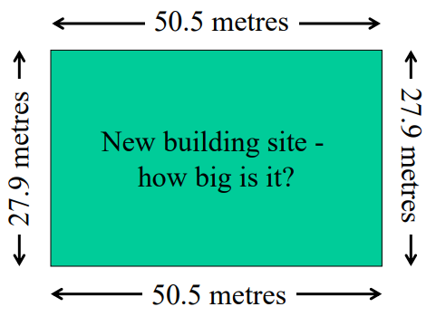

Aims and Objectives
To produce map of a small area, using tape measurements.
To transfer small project to the ground using tapes and accessories
To set out perpendicular distance between two points using shortest distance and Double right-angle prism.
To familiarize and be able to work with the various linear measuring equipment
Instruments
The following are the instruments used to carry out the work:
- Double right-angle prism
- Ranging poles
- Plumb bob
- Polymer tape
Methodology
Two methods were used to complete the work.
- Offsetting using Double right-angle prism
- Offsetting using Shortest Distance
Offsetting Using Shortest Distance
The procedure outlined below was adopted during the lab work for short distance method
- The baseline AB was marked used as the reference as shown in the sketch.
- Lines were established, perpendicular to the reference line, from each point we were mapping.
- Distances from the reference point A were measured along the reference line AB to the perpendicular and the length of the perpendicular.
- All the measurements were recorded in our sketchbook
Offsetting Using Double Right-Angle Prism
- The baseline AB was used as described in procedure one above.
- Distances and offsets available from the project procedure above were used to set out on the ground each of the points.
- First distance was measured from B along the line BA.
- Prism was then placed over the marked point from the first distance we measured.
- Third point was observed, which is marking the direction of the perpendicular to the required point.
- Offset along the established perpendicular was measured starting from the baseline.
- The point and its number was marked and checked how it matched with the required points
- This step was done for all the points
The figure shown below is the sketch of the survey area and the measured distances.

Sketch of the survey Area
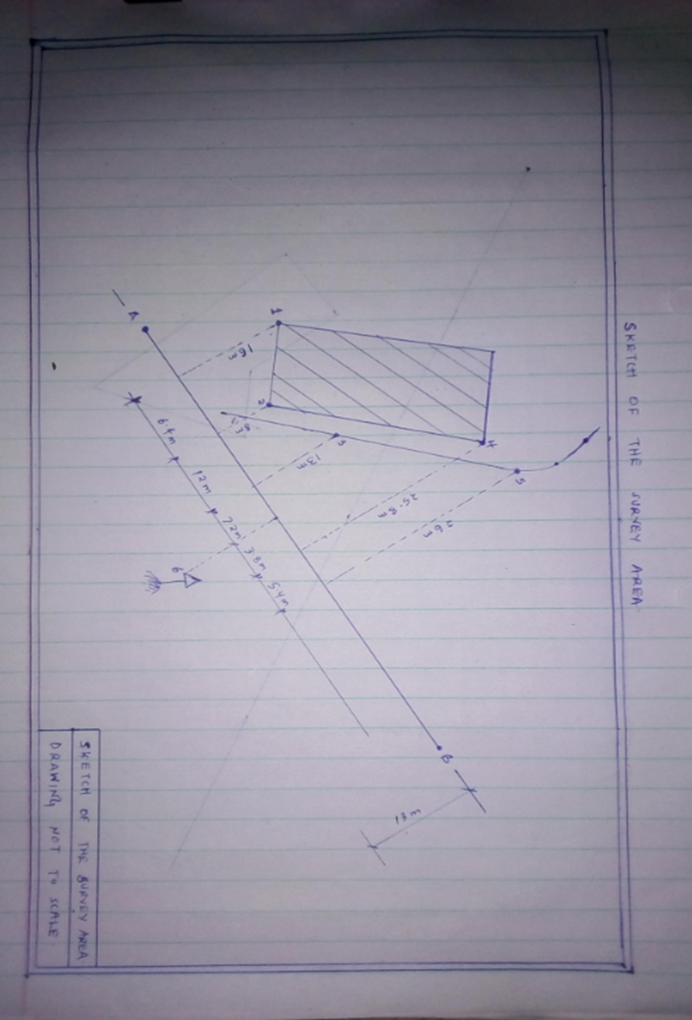

Drawn to scale 1:500
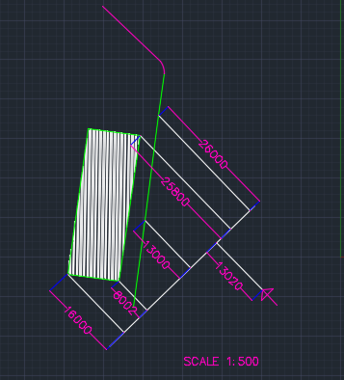
Points from Reference lines AB | Original Measured Distance | Distance Measured during setting out | Error
1 | 16 | 15.86 | -0.14
2 | 8 | 8.08 | 0.08
3 | 13 | 13.04 | 0.04
4 | 25.8 | 25.88 | 0.08
5 | 26 | 25.92 | -0.08
6 | 13 | 13.06 | 0.06

Measurement Error
The error at each point is calculated as
Final Measurement – Original Measurement
For point 1
Error = 15.86 – 16
= -0.14m
For point 2
Error = 8.08 – 8
= 0.08m
For point 3
Error = 13.04 – 13
= 0.04m
For point 4
Error = 25.88 – 25.08
= 0.08m
For point 5
Error = 25.92 – 26
= -0.08m
For point 6
Error = 13.06 – 13
= 0.06m

Average Error
Average error is calculated as
summation of the point errors/Number of points
(0.06-0.08-0.14+0.08+0.04+0.08)/6
= 0.006667m
Conclusion
When carrying out linear measurements the length of the baseline was measured using the drag tape this length was found to be 40m.There tape had no lose in length however sag, tension and slope corrections could not be applied as instruments required for measurement of temperature tension were not provided. The temperature, sag and tension could be the main cause of the errors reported above.
Recommendations
If necessary, it should be feasible in smaller groups, or the number of tools per group should be increased. Site survey areas should be much more rugged terrain so that many survey methods are involve in chaining.

References
Richards, D., & Hermansen, K. (1995). Use of extrinsic evidence to aid interpretation of deeds. Journal of Surveying Engineering, (121), 178.
A History of the Rectangular Survey System by C. Albert White, 1983, Pub: Washington, D.C: U.S. Dept. of the Interior, Bureau of Land Management: For sale by Supt. of Docs., U.S. G.P.O.,
Ronalds, B.F. (2016). Sir Francis Ronalds: Father of the Electric Telegraph. London: Imperial College Press.
Turner, Gerard L'E. Nineteenth Century Scientific Instruments, Sotheby Publications, 1983,

